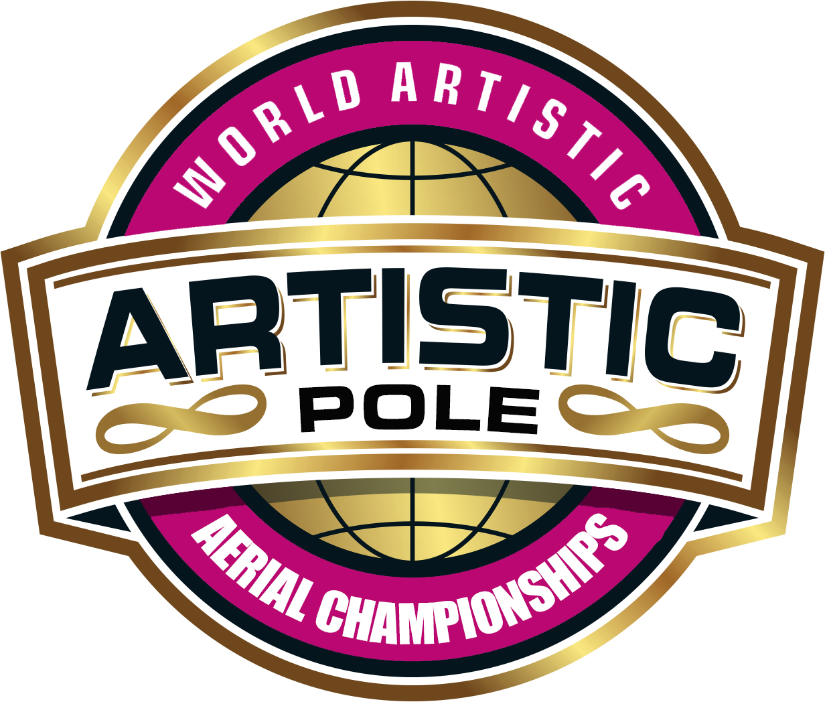
ARTISTIC AERIAL POLE THEME / TECHNICAL SHEET
Performer(s): |  | Date:
Country/Region: |  | Federation:
Division: |  | Category:
THEME: Please give a brief overview of your performance theme
PROPS (other than human props):
Please give full details including prop size, time to install and remove, assistance required, storage needs
HUMAN PROPS: Please give full details how it adds to your story and how many people will be used as human props
If you are removing costume please explain how and why
By ticking the boxes I/we confirm that: | By ticking the boxes I/we confirm that my/our performance:
☐ I/we added photo(s) of my / our costume  ☐ I/we added photo(s) of props  ☐ I/we added music | ☐ does not contain any nudity  ☐ does not contain weapons or the simulation of weapons  ☐ does not contain anything sexist, racist or homophobic  ☐ does not contain any violence or religious connotation  ☐ is suitable for family viewing
Performers’ signature : | Coaches signature :

